**DERIVATIVE VECTOR CALCULUS**

**Scalar Point Function**

* Imagine a region in space, that consists of many points.
* To these points, a **unique value** or **function** is associated with all of them.
* We call this value/function as ***scalar point function***.
* **Stationary scalar field:** Scalar field independent of time.

**Scalar point function:**



**Vector Point Function**

* A commonly associated vector to each point in a given region.
* We call this commonly associated vector value/function as ***vector function***.
* **Stationary vector field:** Vector field independent of time.

**Vector point function:**



**Vector Differential Equation**

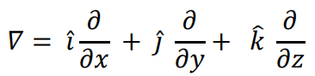

**Gradient of a Scalar Field**

* The formula to **convert** a given ***scalar field*** into a ***vector field***.

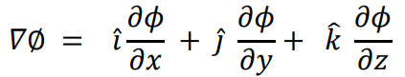

**Unit Normal Vector**

* A ***normal vector*** to a given **surface**.

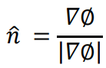

**For Example:**

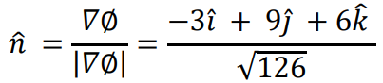

**Directional Derivative**

* A **derivative** of a given ***vector function*** toward a **given direction**.

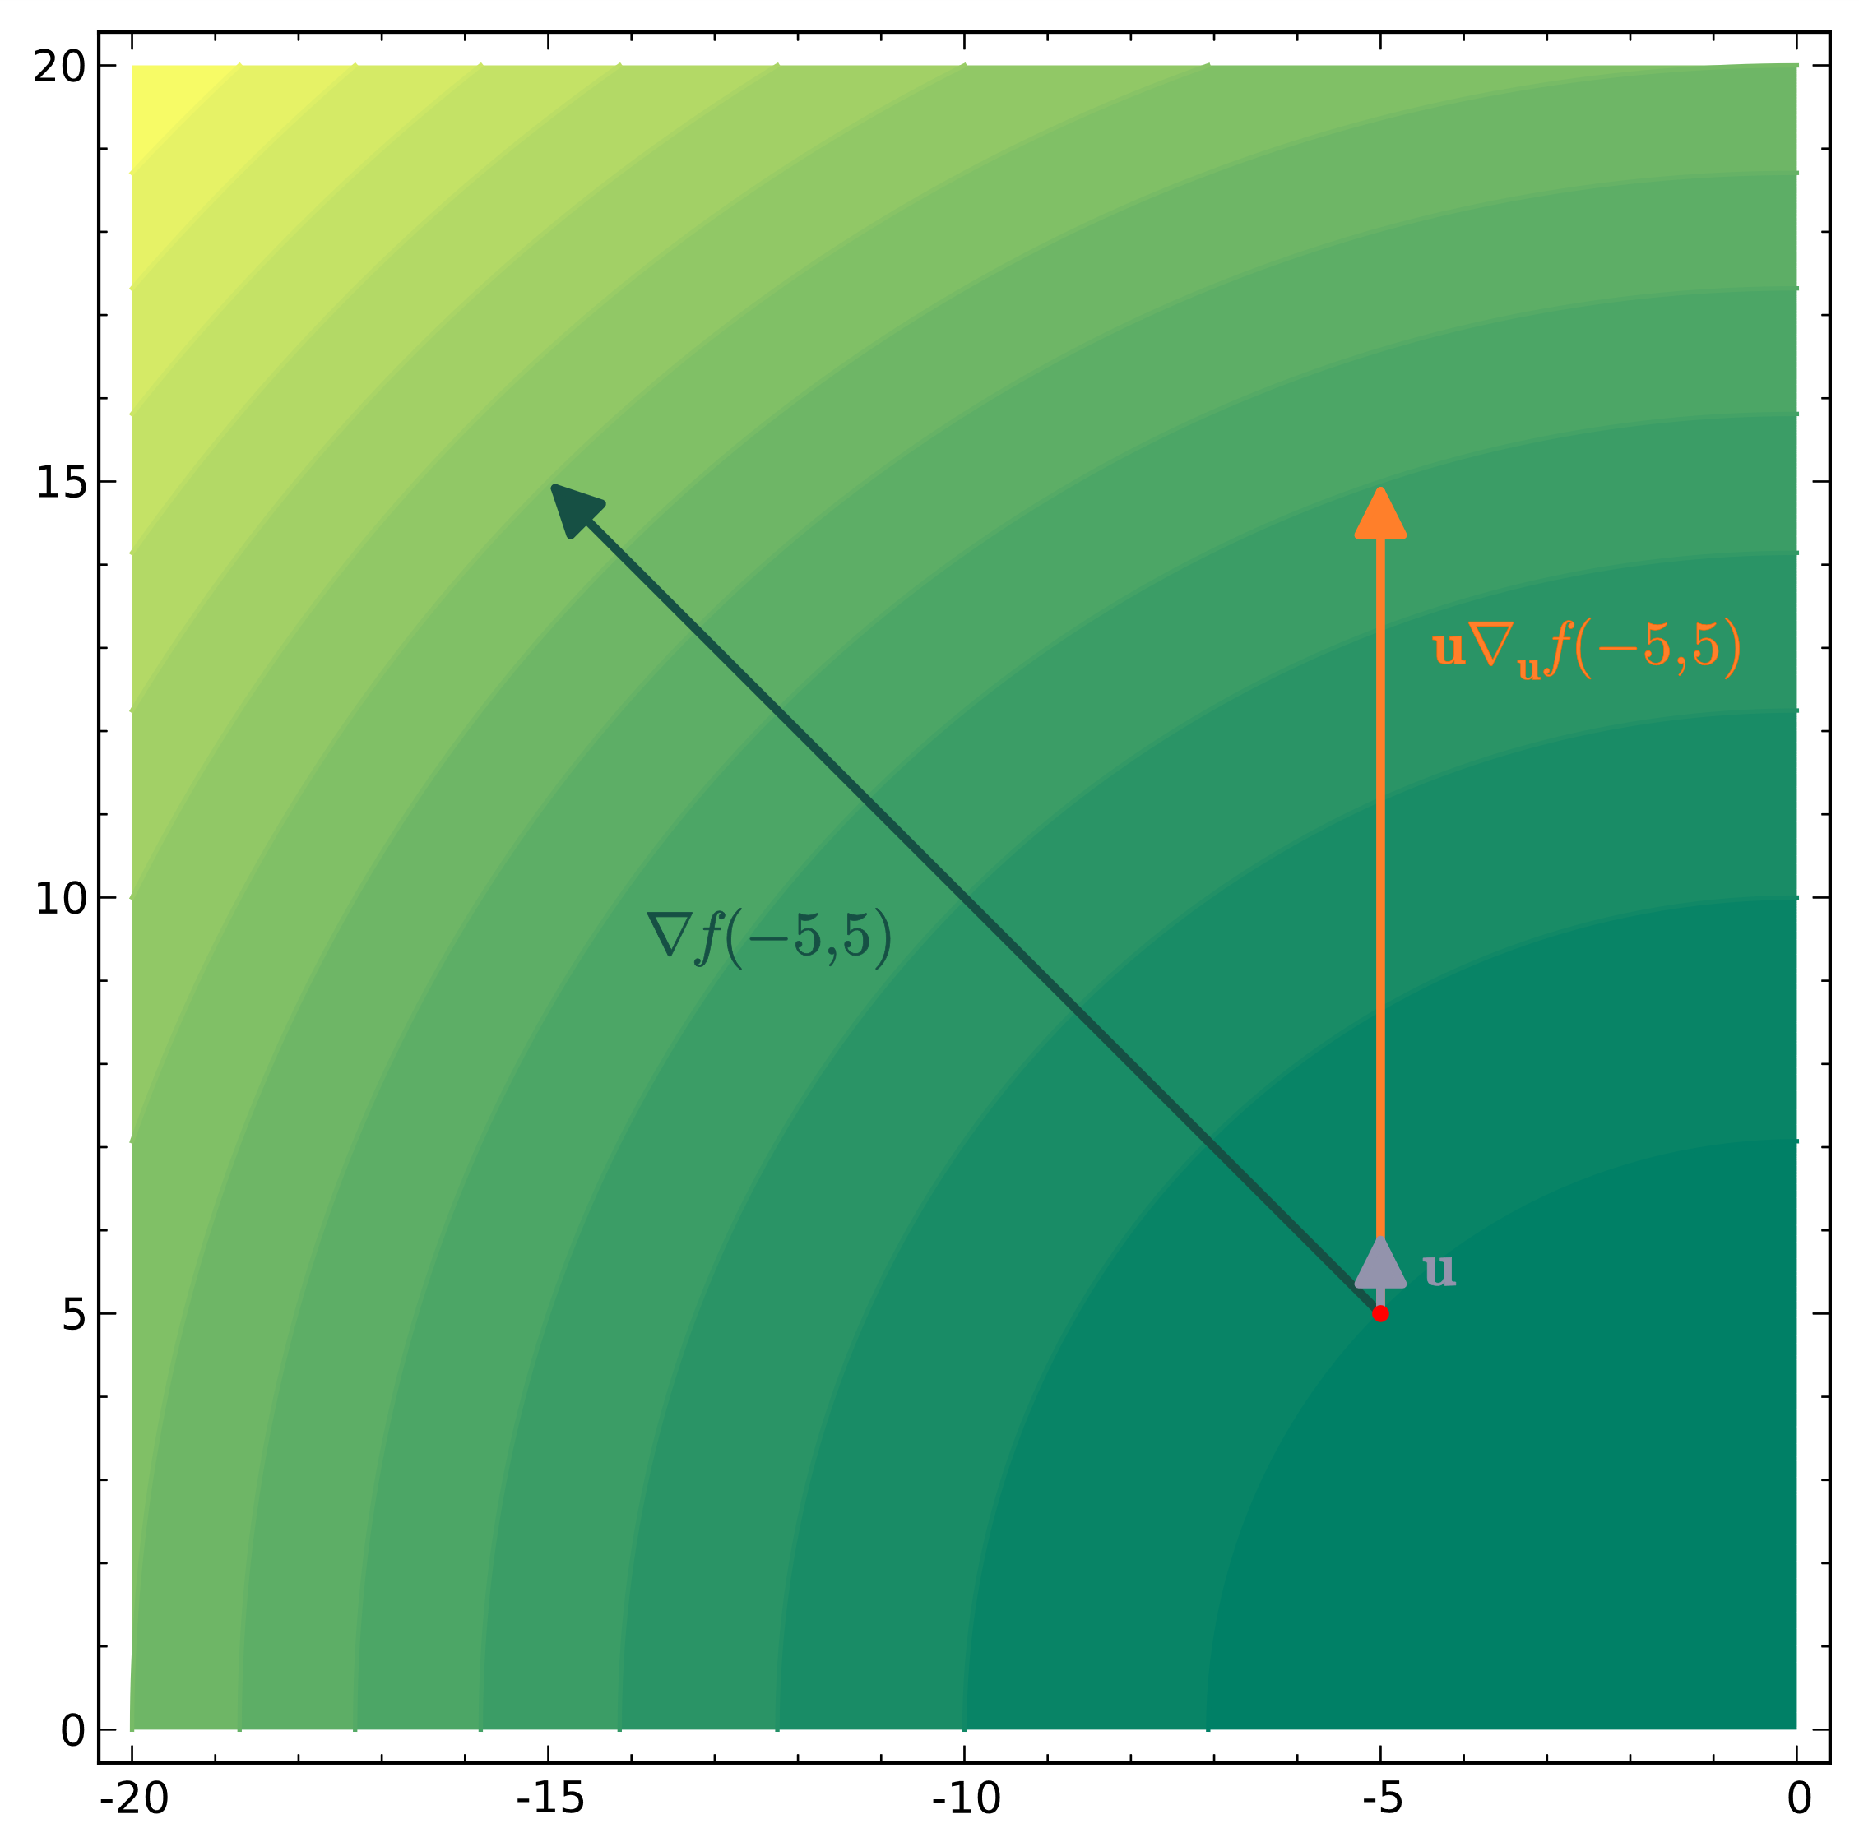

**Directional derivative:**



**For example:**



**Solution:**

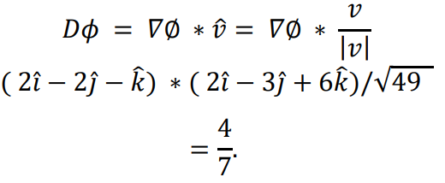

**Maximum directional derivative:**



**Divergence of a Vector Function**

**For a given vector function:**



**Divergence:**



**Solenoid/incompressible divergence:**



**Notice that it contains the dot (.) symbol.**

* In **fluid mechanics**, **divergence free vector field** is known as ***incompressible***.
* In **electromagnetism**, **divergence free vector field** is known as ***solenoidal***.

**Curl of a Vector Function**

**For a given vector function:**



**Curl:**

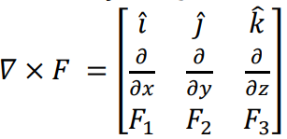

**Notice that it contains the cross (x) symbol.**

**Irrotational/conservative curl:**

